**Medical Image Viewer**

**Video Link -** [**https://www.loom.com/share/5b173e41e3da4650a06c41411e311fee**](https://www.loom.com/share/5b173e41e3da4650a06c41411e311fee)

**(A) Core Changes:**

Path - moodle project/course/modeedit.php

Go to line 150 in **modedit.php** enter and paste below code: I have also shared the modedit.php page for easier comparison or

Search this line: else if ($fromform = $mform->get_data()) and press enter and paste below code

// ============= Added for handelling image upload: Start ==============

// receiving the image and updating in db.

$idnumberk = $fromform->mivimage;

$coursek = $fromform->course;

$time = time();

$imagekk = $mform->get_new_filename('mivimage');

// for edit case course module id

$coursemodulek = $fromform->coursemodule;

// For insert case course module id

if($coursemodulek == 0) {

$coursemodulefreshSql = $DB->get_record_sql("

SELECT id FROM {course_modules} ORDER BY 1 DESC LIMIT 1

");

// if db has no value set coursemodule to 1, otherwise new course module id will be (last id + 1)

if(empty($coursemodulefreshSql)) {

$coursemodulek = 1;

} else {

$coursemodulelast = $coursemodulefreshSql->id;

$coursemodulek = $coursemodulelast + 1;

}

}

$DB->execute("INSERT INTO mdl_medicalimageviewer_images(itemid, course, coursemodule, image, time_created) VALUES($idnumberk, $coursek, $coursemodulek,'$imagekk', $time)");

// =========== Added for handelling image upload: End ==================

**(B) Installation:**

Step 1: Install the medical image viewer plugin from Site Admin → Plugins → Install Plugin

Step 2: Once the plugin is installed go to the course page where you want to install the activity

Step 3: Turn Edit On → Click on Add an activity → medical image viewer. Write your image name, upload the image(eg. skull.vtx) in **Upload Medical Image**

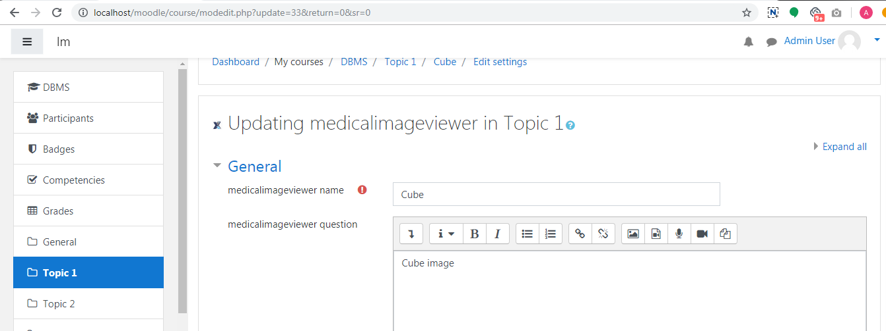

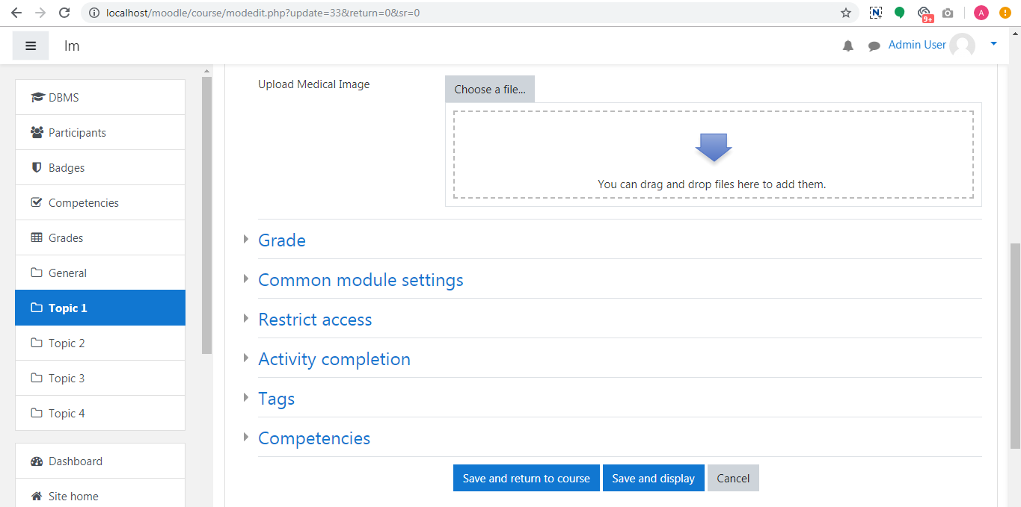

Step 4: Now click on the activity, your image will load.